Boothferry Fitmums Running Routes
Route 8 – HFRS Base

HQ cross road, R Summergroves, L Santolina Way, R Robinia Drive, R Summergroves to HQ  BoothFM - Route 8; 1 mile. Mapometer.com running route #5506594 | 1 mile
L Summergroves, L Hessle Rd, R Eastgate onto Swinegate, L Southgate, L Hull Rd round the square, R Itlings Lane, L Windmill Way onto Green Lane onto Sainsbury Way, L Priory Way, R Hessle Rd, R Summergroves to HQ  BoothFM - Route 8; 2 miles. Mapometer.com running route #5506595 | 2 miles
HQ L Summergroves, L Hessle Rd, cross onto Hull Rd, L Prestongate, R The Weir, L Salisbury St, L Barrow Lane, L Ferriby Rd, R South Lane, L Station Road leads onto Ferry Rd, L Buttfield Rd, R Hull Rd, L Northolme Rd, R Glamis Rd, R Belvedere Rd, R First Lane, L Hull Rd, onto Hessle Rd R Summergrove to HQ  BoothFM - Route 8; 3 miles. Mapometer.com running route #5506597 | 3 miles
HQ L Summergroves, L Hessle Rd cross onto Hull Rd, L Prestongate, R The Weir, L Salisbury St, L Barrow Lane, L Ferriby Rd, R South Lane, L Station Rd leads onto Ferry Rd, L Buttfield Rd, R Hull Rd, L Northolme Rd, R Beverley Rd, R Richmond Rd to Seaton Rd, L Seagran Ave, R Winthorpe Rd, R First Lane, L Hull Rd to Hessle Rd, R Summergroves HQ  BoothFM - Route 8; 4 miles.. Mapometer.com running route #5506599 | 4 miles
L Summergroves, R Hessle Rd, L Pickering Rd cross roundabout continue on Pickering Rd, R Sunbeam Rd, L Eastfield Rd, R Belgrave Rd, L Anlaby Rd, L Plantation Drive West, L Woodland End, R Southern Drive, R Holme Close, R Park Lane West, L Coppice Side, R Mead Walk, L Plantation Drive West, R Anlaby Rd, R Pickering Rd, R Lexington Drive follow this round bear right at junction straight onto St Joseph Dr, R Pickering Rd cross roundabout Pickering Rd, R Hessle Rd, L Summergroves to HQ  BoothFM - Route 8; 5 miles.. Mapometer.com running route #5506600 | 5 miles
HQ L Summergroves, L Hessle Rd onto Hull Rd, R First Lane, L Boothferry Rd, L Beverley Rd, R Swanland Rd, L Barrow Lane, R Tranby Ave, L Heads Lane, L Davenport Ave, R Chesnut Avenue, L Station Rd, L Bon Accord Rd, L Buttfield Rd, R Hull Rd, L Northolme Rd, R Beverley Rd, R Richmond Rd onto Seaton Rd, R First Lane, L Hull Rd onto Hessle Rd, R Summergroves HQ  BoothFM - Route 8; 6 miles.. Mapometer.com running route #5506602 | 6 miles

ROUTE 8
1 | 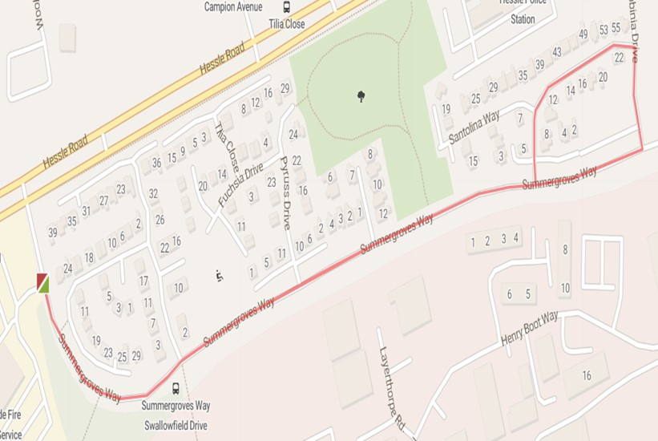
2 | 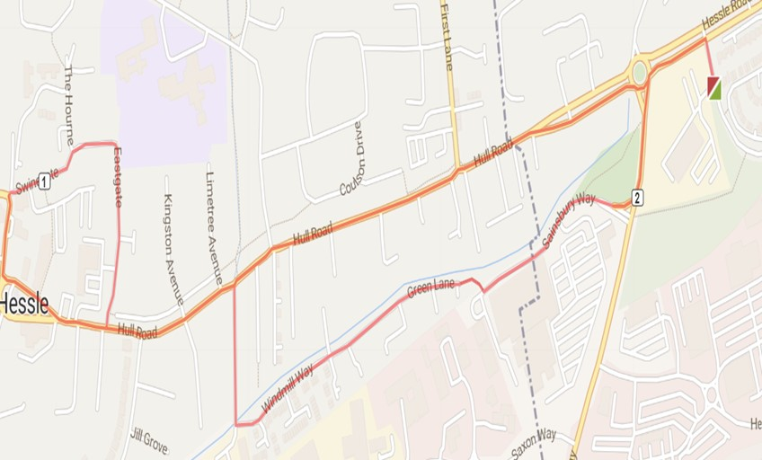
3 | 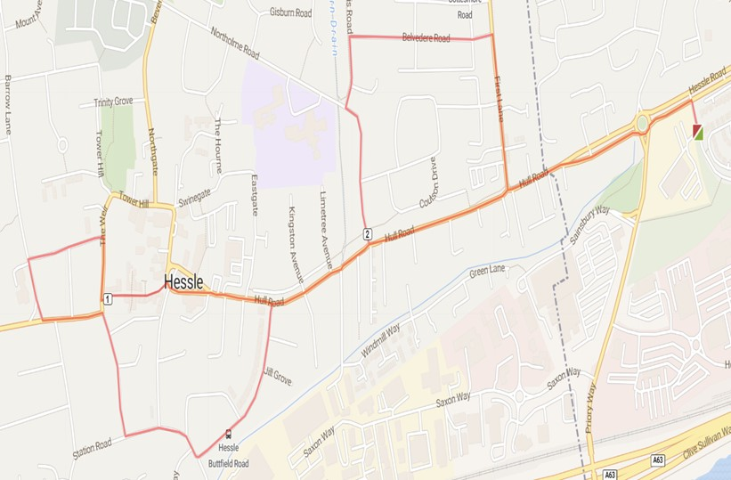
4 | 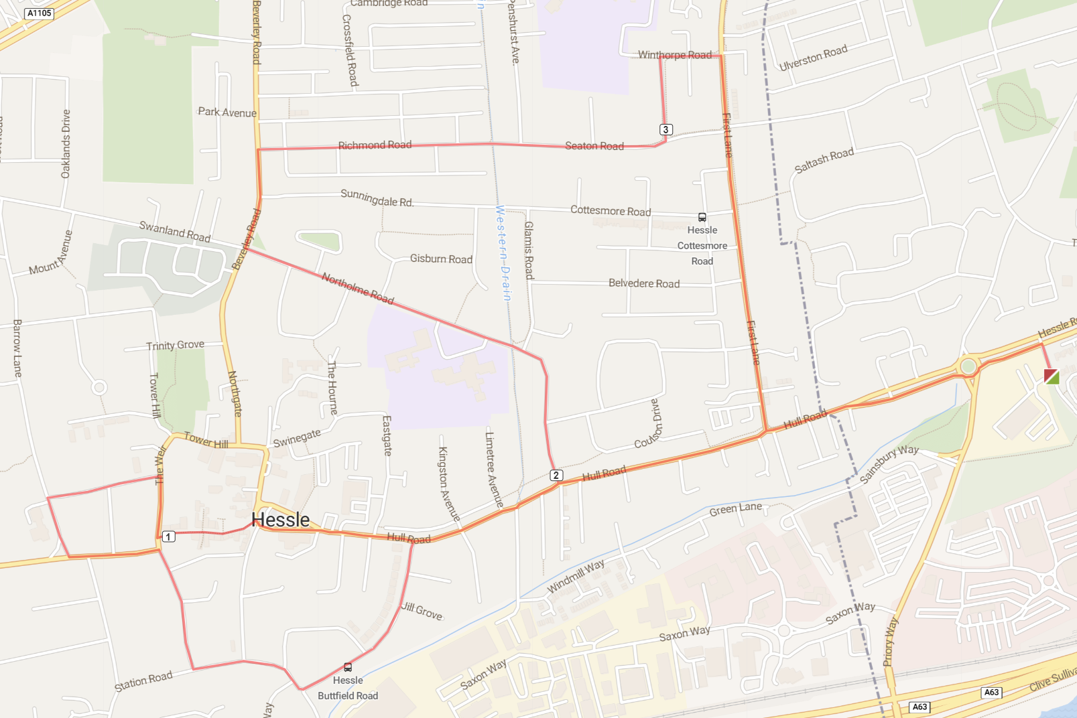
5 | 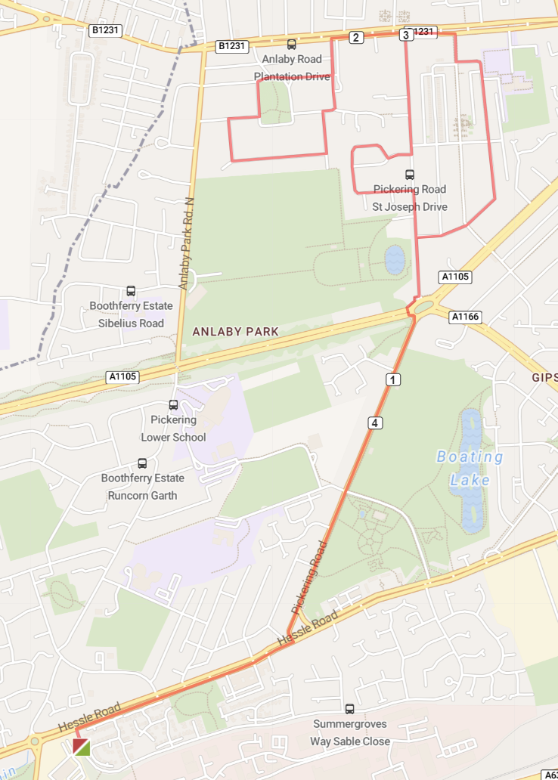
6 | 