Boothferry Fitmums Running Routes
Route 2A (Reverse) – HFRS Base

Exit base and turn R onto Hessle Rd, Caution: care when crossing road, L Tilbury Rd, R Campion Ave, L Burnham Ave, L APRS, L Tilbury Rd and onto APRS, L Hessle Rd and back to base. Caution when crossing road.  BoothFM - Route 2A; 1mile. Mapometer.com running route #5489870 | 1 mile
Exit base and L onto Hessle Rd. Caution: cross road with care, straight onto Hull Rd. R First Lane, up to junction with Seaton Road, turn round, back down First Lane, R Belvedere Rd, L Glamis Rd, L Northolme Rd, R Hull Rd, L Itlings Lane. Caution: use crossing, L Windmill Way onto Green Lane, onto Sainsburys Way, L Priory Way, R Hessle Rd and back to base. Caution: use care crossing road.  BoothFM - Route 2A; 2mile. Mapometer.com running route #5489873 | 2 miles
Exit base and L onto Hessle Rd. Caution: cross road with care, straight onto Hull Rd. R First Lane, L Cottesmore Rd, onto Sunningdale Rd, R Beverley Rd, L Boothferry Rd, L Swanland Rd, straight over to Northolme Rd. Caution; use crossing, L Hull Rd, onto Hessle Rd and back to base. Caution: use care crossing road.  BoothFM - Route 2A; 3mile. Mapometer.com running route #5489875 | 3 miles
Exit base R Summergroves Way to The Groves, turn round, L Hessle Rd, Caution: cross road with care, onto Hull Road Caution: use crossing, R First Lane, L Cottesmore Rd, L Glamis Rd, R Northolme Rd, straight over to Swanland Rd, Caution: use crossing, L Barrow Lane, L Ferriby Rd, onto Prestongate, R Southgate. Caution: narrow paths, L Ferry Rd, L Buttfield Rd, R Hull Rd, R Itlings Lane, L Windmill Way onto Green Lane, onto Sainsburys Way. L Priory Way, R Hessle Rd and back to base. Caution: cross road with care.  BoothFM - Route 2A; 4mile. Mapometer.com running route #5489878 | 4 miles
Exit base and turn L onto Hessle Rd, Caution: use care crossing road, onto Hull Road, R Northolme Rd, R Beverley Rd, R Sunningdale, onto Cottesmore Rd, L First Lane, L Seaton Rd onto Richmond Rd, R Beverley Rd, L Boothferry Rd, L Heads Lane, L Ferriby Rd, R South Lane. Caution: narrow paths, L Station Rd onto Ferry Rd, L Buttfield Rd, R Hull Rd, onto Hessle Rd and back to base. Caution: care when crossing road.  BoothFM - Route 2A; 5mile. Mapometer.com running route #5489881 | 5 miles
Exit base and turn R onto Summergroves Way, run to santolina Way and turn round, L onto Hessle Rd onto Hull Rd, Caution: use care crossing road, R First Lane, L Boothferry Rd, straight, L Heads Lane, L Ferriby Rd, R Chestnut Ave, R Davenport Ave, L Woodfield Lane, L Southfield, follow road round to R, Caution: narrow paths and tree roots, L Station Rd, L Southgate Caution; narrow paths, R Hessle Square onto Hull Rd, onto Hessle Rd and back to base Caution: cross road with care.  BoothFM - Route 2A; 6mile. Mapometer.com running route #5489883 | 6 miles

ROUTE 2A
1 | 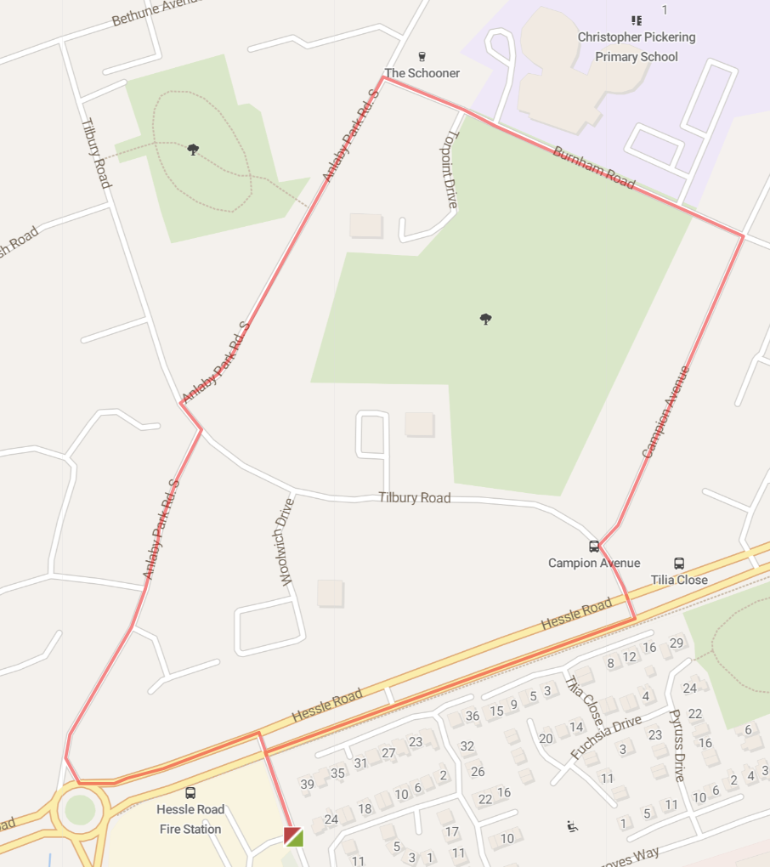
2 | 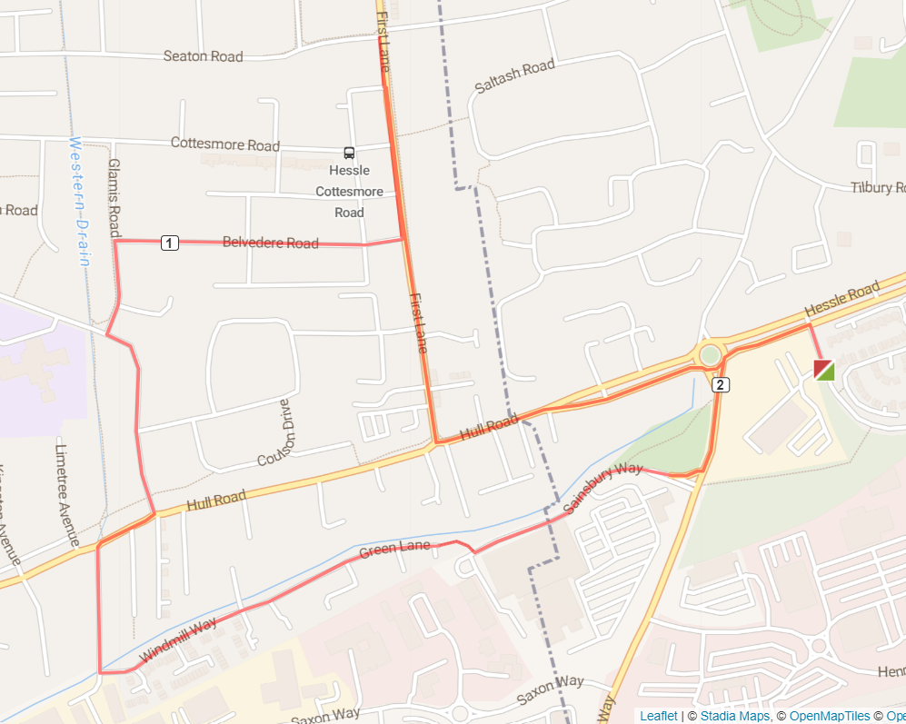
3 | 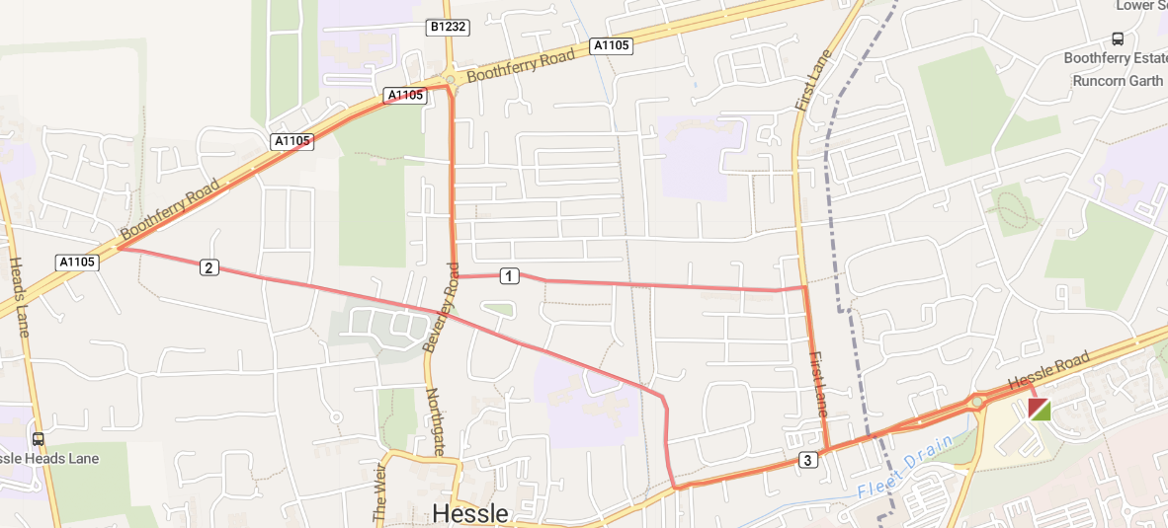
4 | 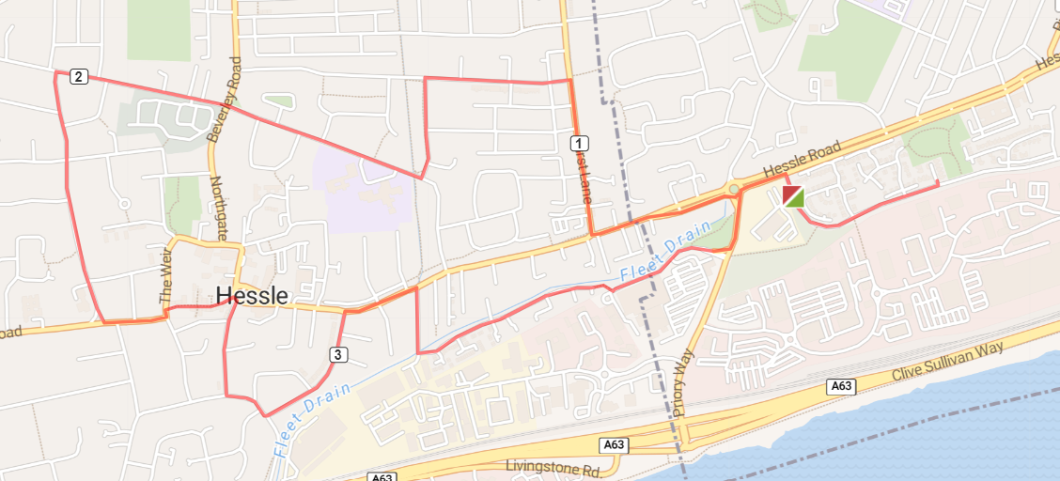
5 | 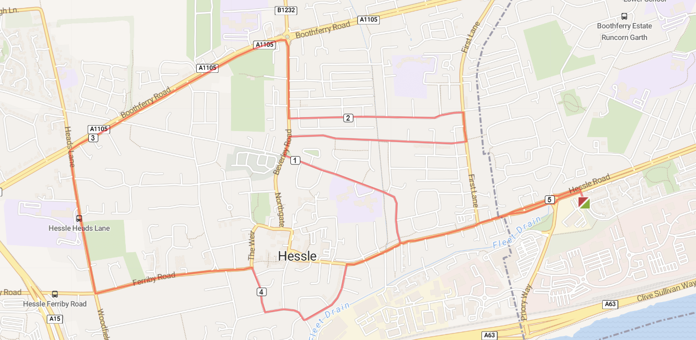
6 | 