Boothferry Fitmums Running Routes
Route 5a (Summer) – HFRS Base

Exit base, R Summergroves Way, Cross using crossing, R Hessle Rd, L through park gates, straight through park, L onto Pickering Rd, R Hessle Rd, back to base – caution crossing road  BoothFM Route 5A (summer); 2 miles. Mapometer.com running route #5506574 | 2miles
L Hessle Rd, onto Hull Rd, caution at crossing, continue into Hessle Sq, straight up Prestongate, L The Weir, L South Lane, R Station Rd, over footbridge, R Redcliff Rd, L Cliff Rd, caution crossing road, L riverside footpath, L footpath onto Livingstone Rd, L footbridge onto Ferry Rd, R Buttfield Rd, R Hull Rd onto Hessle Rd, caution crossing road, back to base.  BoothFM Route 5A (summer); 3 miles. Mapometer.com running route #5506575 | 3 miles
L Hessle Rd, onto Hull Rd, caution at crossing, continue into Hessle Sq, straight up Prestongate, L The Weir, R Ferriby Rd, L Chestnut Ave, R Davenport Ave, L Woodfield Lane, R Cliff Top Lane, onto footpath into Country Park, L down steps, caution: steep, L into underpass towards river, riverside path towards Hessle Haven, L footpath to Livingstone Rd, L footbridge onto Ferry Rd, R Buttfield Rd, R Hull Rd onto Hessle Rd, caution crossing road, back to base.  BoothFM Route 5A (summer); 4 miles. Mapometer.com running route #5506577 | 4 miles
L Hessle Rd, onto Hull Rd, R Eastgate, L Eastgate on to Swinegate, onto Tower Hill, L The Weir, R Ferriby Rd, L Chestnut Ave, R Davenport Ave, L Woodfield Lane, R Cliff Top Lane, onto footpath into Country Park, L down steps, caution: steep, R to complete short circuit of park, exit via underpass towards Mill, L riverside path towards Hessle Haven, L footpath to Livingstone Rd, L footbridge onto Ferry Rd, R Buttfield Rd, R Hull Rd, R Itlings Lane, L Windmill Way onto Green Lane, Sainsbury Way, L Priory Way onto Hessle Rd, caution crossing road, back to base.  BoothFM Route 5A (summer); 5 miles.. Mapometer.com running route #5506578 | 5 miles
L Hessle Rd, onto Hull Rd, R Eastgate, L Eastgate on to Swinegate, R Northgate, L Trinity Gr, R Brunswick Gr, L Westbourne Gr, L Barrow Lane, R footpath into housing estate, L Thornton Close, L Elsham Rise, R Ferriby Rd, L Woodfield Lane, L Cliff Top Lane, onto footpath into Country Park, L down steps, caution: steep, full circuit of park, exit via underpass towards Mill, L riverside path towards Hessle Haven, L footpath to Livingstone Rd, L footbridge onto Ferry Rd, R Buttfield Rd, R Hull Rd, R Itlings Lane, L Windmill Way onto Green Lane, Sainsbury Way, L Priory Way onto Hessle Rd, caution crossing road, back to base.  BoothFM Route 5A (summer); 6 miles. Mapometer.com running route #5506579 | 6 miles

ROUTE 5A
2 | 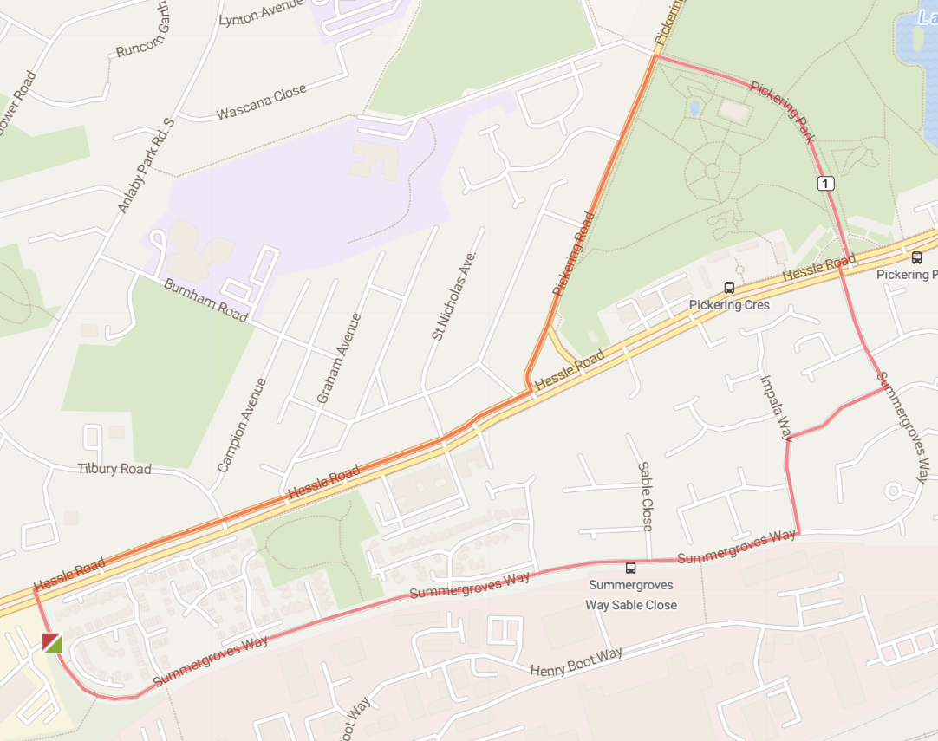
3 | 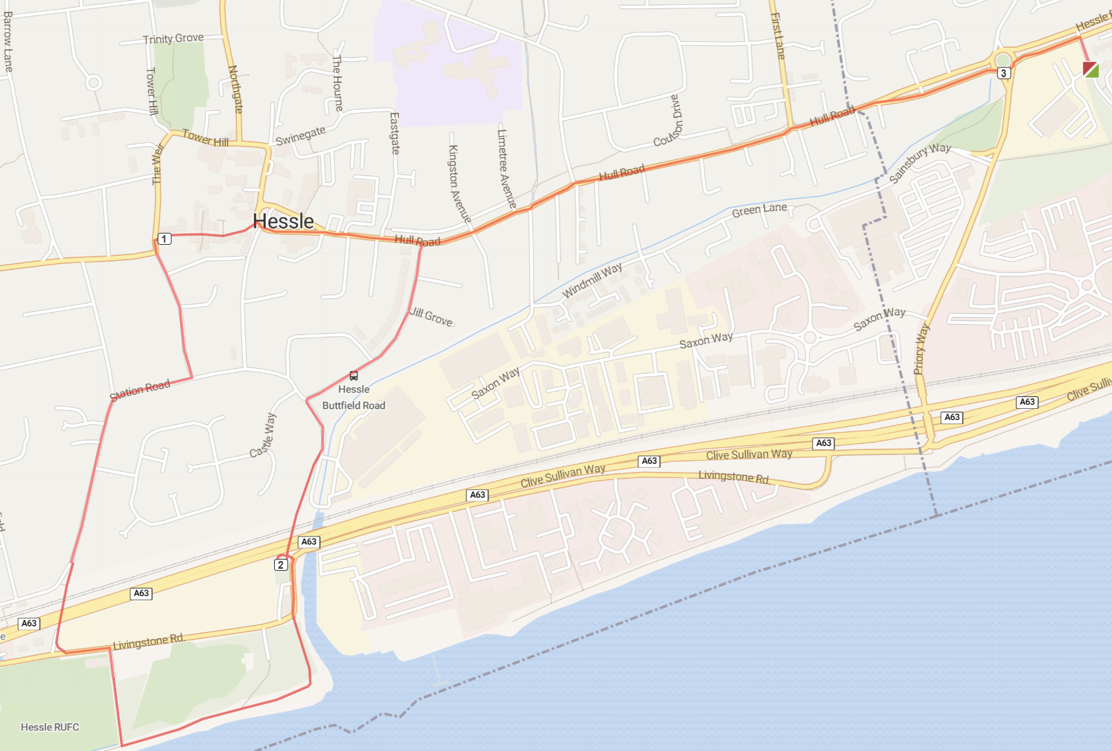
4 | 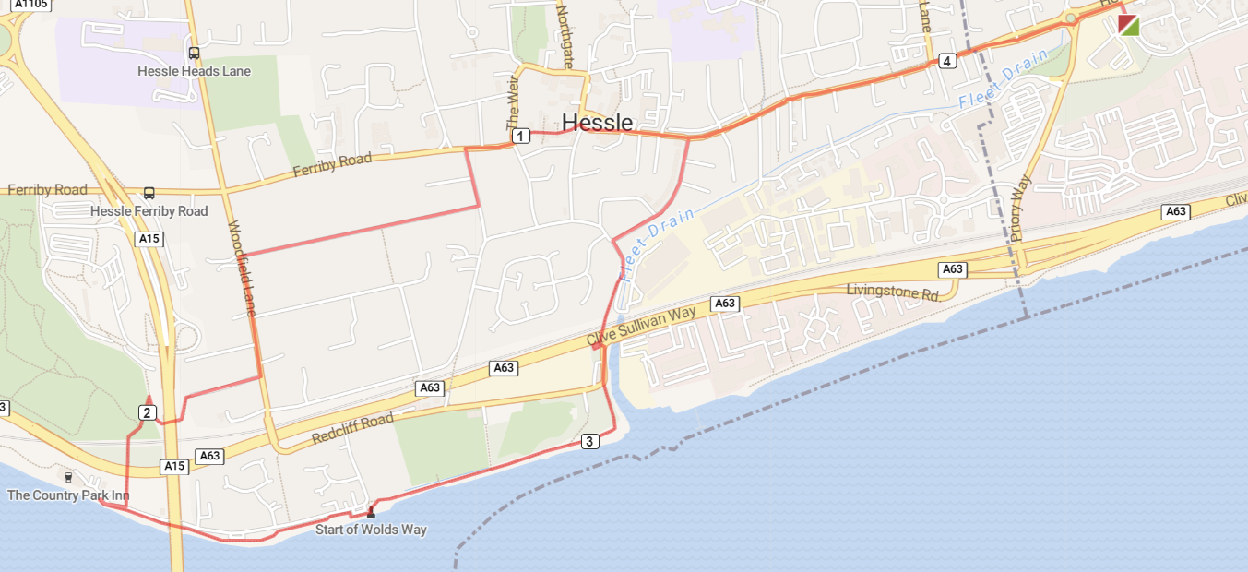
5 | 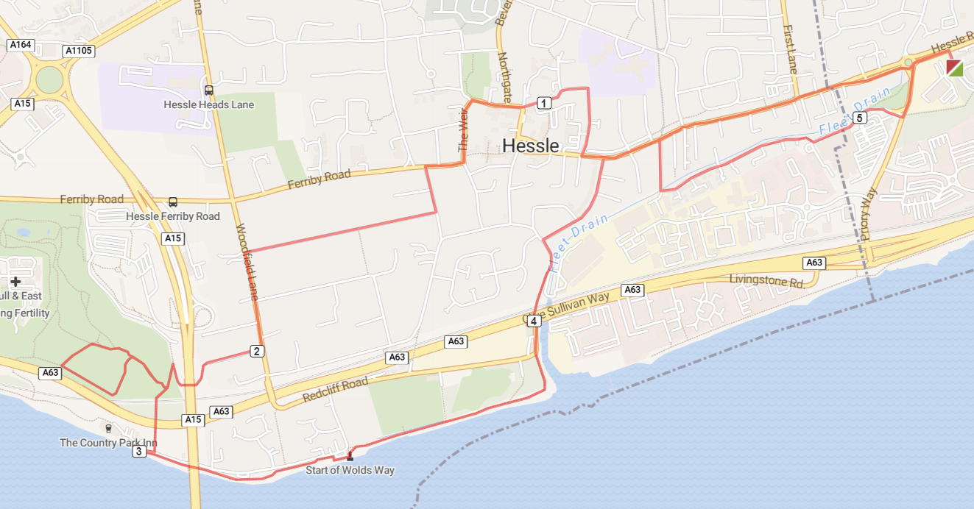
6 | 