Boothferry Fitmums Running Routes
Route 2 – HFRS Base
Exit base and turn L onto Hessle Rd, Caution: use care crossing road, R APRS, L Tilbury Rd, R APRS, R Burnham RD, R Campion Ave, L Tilbury Rd, R Hessle Rd and back to base. Caution: care when crossing road  BoothFM - Route 2; 1 mile. Mapometer.com running route #5499748 | 1 mile
Exit base and turn L onto Hessle Rd, L onto Priory Way. Caution: care when crossing road, R Sainsbury Way using footpath, R Green Way using footpath, onto Windmill Way, R Itlings Lane, R Hull Road. Caution; use crossing, L foothpath to Northolme Rd, cross road to Glamis Rd, Caution: cross road with care, R Belvedere Rd, L First Lane to junction with Seaton Rd, Turn R First Lane, L Hull Rd onto Hessle Rd and back to base. Caution: care crossing road.  BoothFM - Route 2; 2 miles. Mapometer.com running route #5499749 | 2 miles
Exit base and turn L onto Hessle Rd, Caution: use care crossing road, onto Hull Road, R Northolme Rd, straight onto Swanland Rd, Caution; use crossing, R Boothferry Rd, R Beverley Rd, L Sunningdale Rd, onto Cottesmore Rd, R First Lane, L Hull Rd, onto Hessle Rd and back to base. Caution: use care crossing road.  BoothFM - Route 2; 3mile. Mapometer.com running route #5489864 | 3 miles
Exit base and turn L onto Hessle Rd, L onto Priory Way. Caution: care when crossing road, R Sainsbury Way using footpath, R Green Way using footpath, onto Windmill Way, R Itlings Lane, L Hull Rd, L Buttfield Rd, R Ferry Rd, R Southgate Caution: narrow paths use LHS, L Prestongate, L The Weir, R Ferriby Rd, R Barrow Lane, R Swanland Rd, Caution; leaves on paths in winter, straight over to Northolme Rd, Caution: use crossing, L Glamis Rd, R Cottesmore Rd, R First Lane, L Hull Ro onto Hessle Rd Caution: use care crossing road. R Summergroves to The Groves turn to make up mileage, turn & back to base  BoothFM - Route 2; 4 miles. Mapometer.com running route #5499747 | 4 miles
Exit base and turn L onto Hessle Rd, L onto Priory Way. Caution: care when crossing road, R Sainsbury Way using footpath, R Green Way using footpath, onto Windmill Way, R Itlings Lane, L Hull Rd, L Buttfield Rd, R Ferry Rd, R South Lane. Caution: narrow paths and leaves in winter, L Ferriby Rd, R Heads Lane, R Boothferry Rd, R Beverley Rd, L Richmond Rd, onto Seaton Rd, R First Lane, R Cottesmore Rd, onto Sunningdale Rd, L Beverley Rd, L Northolme Rd, L Hull Rd onto Hessle Rd and back to base. Caution; care crossing road.  BoothFM - Route 2; 5 miles. Mapometer.com running route #5499751 | 5 miles
Exit base and turn L onto Hessle Rd, Caution: use care crossing road, onto Hull Road, into Hessle Square, L Southgate. Caution: narrow paths, R Station Rd, R Southfield, follow rd round to left. Caution: narrow paths and tree roots, R Woodfield Lane. Caution: cross road with care, R Davenport Avenue, L Chestnut Avenue, L Ferriby Rd, R Heads Lane, R Boothferry Rd, straight over at crossing, R First Lane, L Hull Rd and onto Hessle Rd Caution; cross road with care. R Summergroves and up to Santolina Way to make mileage and back to base  BoothFM - Route 2; 6mile. Mapometer.com running route #5489869 | 6 miles

ROUTE 2
1 | 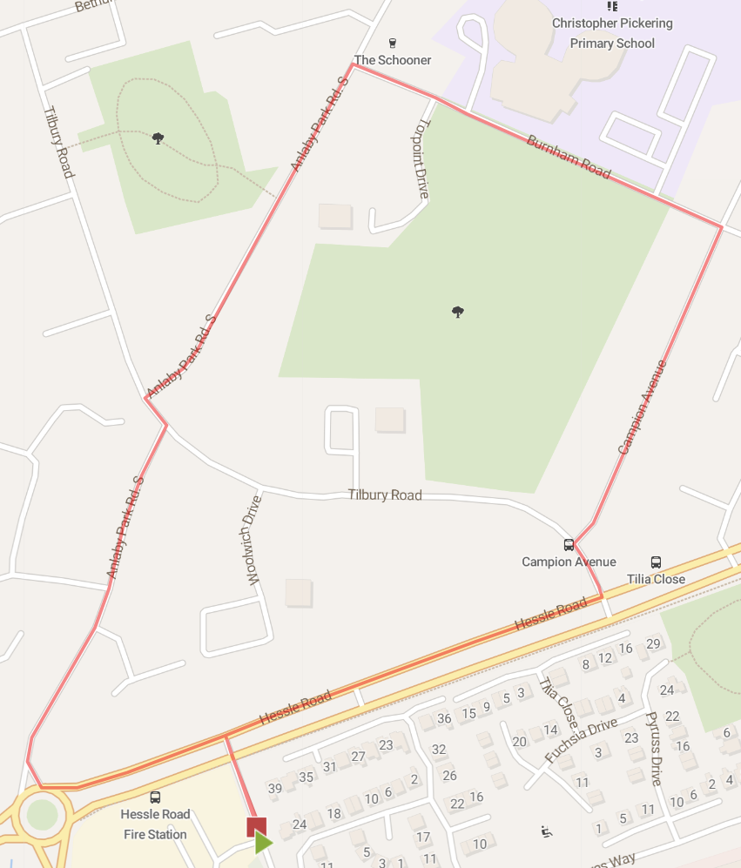
2 | 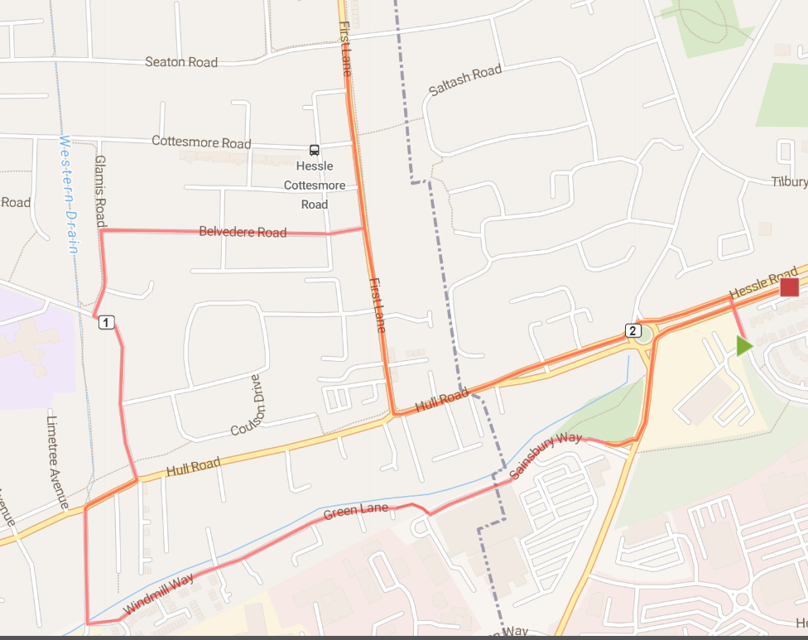
3 | 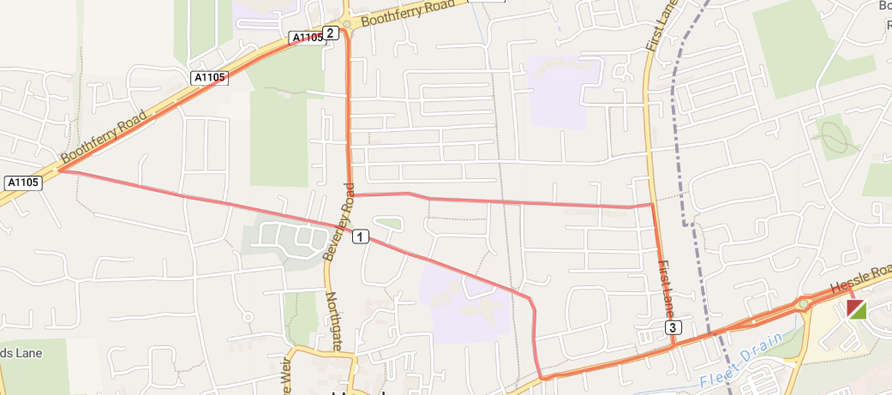
4 | 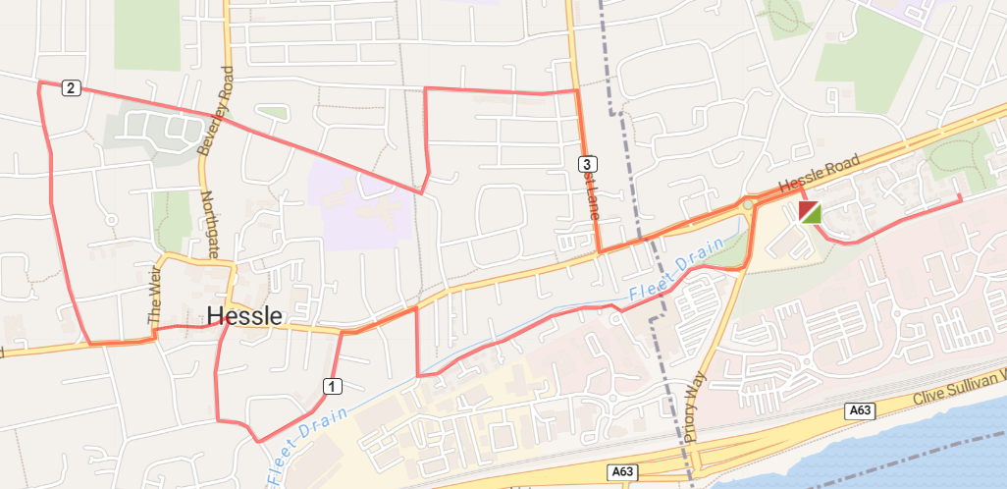
5 | 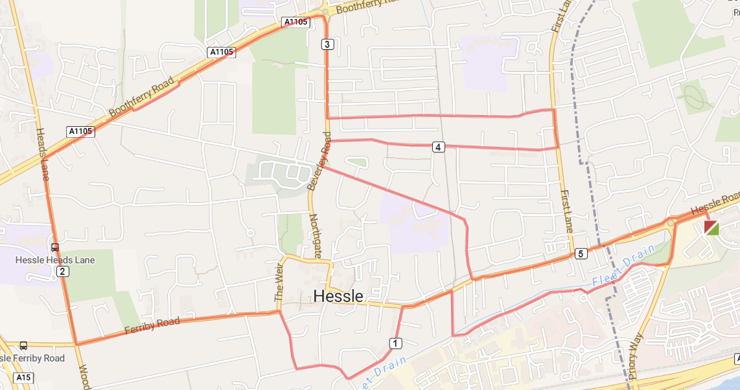
6 | 