Boothferry Fitmums Running Routes
Route 5 (Summer) – HFRS Base

 | 1 mile
Exit base, R Hessle Rd, Caution crossing road, L Pickering Rd, use park side path, R at park gates, through park to Hessle Rd, cross using crossing onto Summergroves Way, follow road round back to base.  BoothFM Route 5 (summer); 2 miles. Mapometer.com running route #5506564 | 2 miles
Exit base, L onto Hessle Road, onto Hull Rd, L Buttfield Rd, L Ferry Rd, over footbridge R Livingstone Rd, at Hessle Haven footpath towards river, R alongside river, R Cliff Rd, R Redcliff Rd, L footbridge (opposite rugby club), R onto Station Rd, L South Lane, onto the Weir, R Prestongate, onto The Square onto Hull Rd, onto Hessle Rd and back to base.  BoothFM Route 5 (summer); 3 miles. Mapometer.com running route #5506566 | 3 miles
Exit base, L onto Hessle Road, onto Hull Rd, L Buttfield Rd, L Ferry Rd, over footbridge R Livingstone Rd, at Hessle Haven footpath towards river, R alongside river, R into underpass into Country Park (by Mill), up steps, R to exit via Cliff Top Lane, L Woodfield Lane, R Davenport Ave, L Chestnut Ave, R Ferry Rd, L the Weir, R Prestongate, onto The Square onto Hull Rd, onto Hessle Rd and back to base.  BoothFM Route 5 (summer); 4 miles. Mapometer.com running route #5506569 | 4 miles
Exit base, L onto Hessle Road, L Priory Way, use crossing, R Sainsbury Way to Green Lane, to Windmill Way, R Itlings Lane, L Hull Rd, L Buttfield Rd, L Ferry Rd, over footbridge, R Livingstone Rd, at Hessle Haven footpath towards river, R alongside river, R into underpass into Country Park (by Mill), L through and round park back to steps, R to exit via Cliff Top Lane, L Woodfield Lane, R Davenport Ave, L Chestnut Ave, R Ferry Rd, L the Weir, R Tower Hill onto Swinegate, L Eastgate, L Hull Rd, onto Hessle Rd and back to base.  BoothFM Route 5 (summer); 5 miles. Mapometer.com running route #5506571 | 5 miles
Exit base, L onto Hessle Road, L Priory Way, use crossing, R Sainsbury Way to Green Lane, to Windmill Way, R Itlings Lane, L Hull Rd, L Buttfield Rd, L Ferry Rd, over footbridge, R Livingstone Rd, at Hessle Haven footpath towards river, R alongside river, R into underpass into Country Park (by Mill), full circuit of park, up steps, R to exit via Cliff Top Lane, L Woodfield Lane, R Ferriby Rd, L Elsham Rise, R Thornton Close onto footpath, L Barrow Lane, R Westbourne Grove, R Brunswick Grove, L Trinity Grove, R Northgate, L Swinegate, L Eastgate, R Eastgate, L Hull Rd, L cycle path, R Northolme Rd, L Hull Rd and back to base.  BoothFM Route 5 (summer); 6 miles. Mapometer.com running route #5506573 | 6 miles

ROUTE 5 Summer
2 | 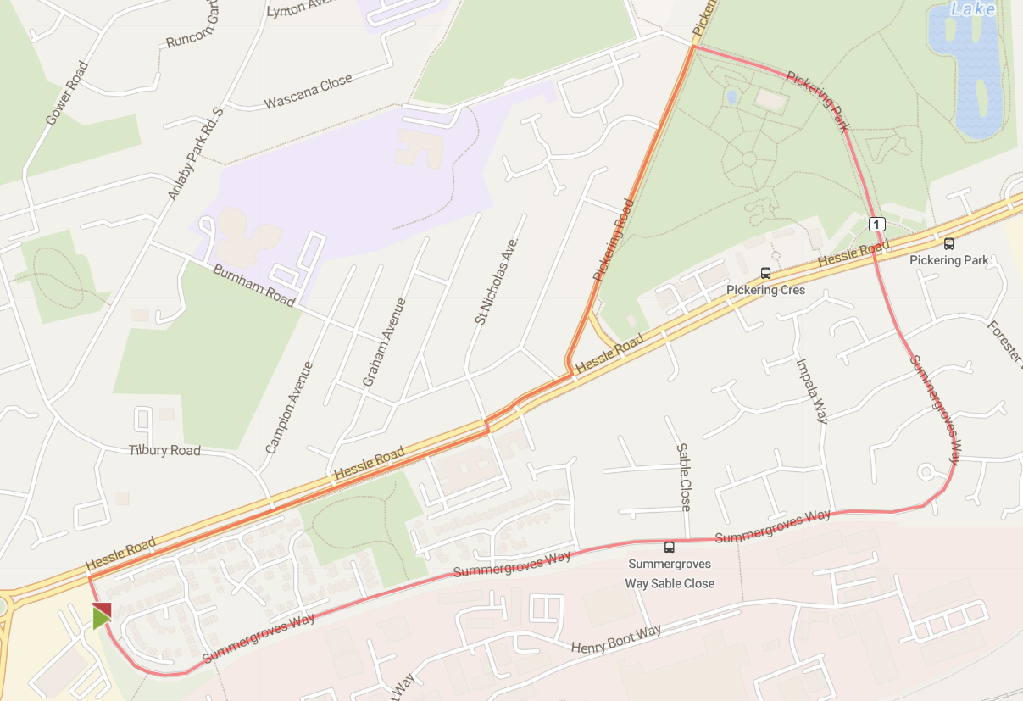
3 | 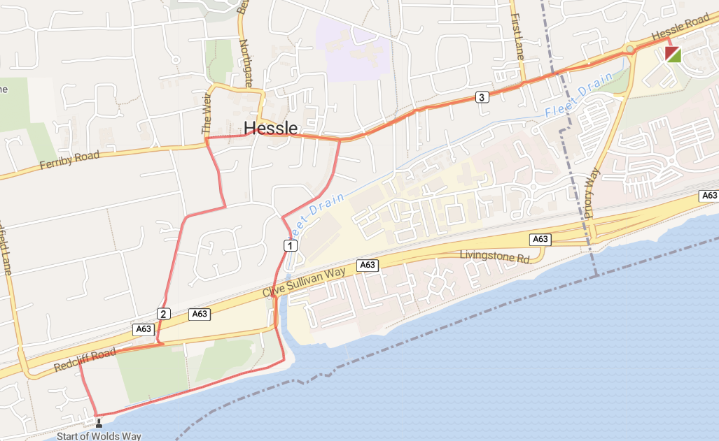
4 | 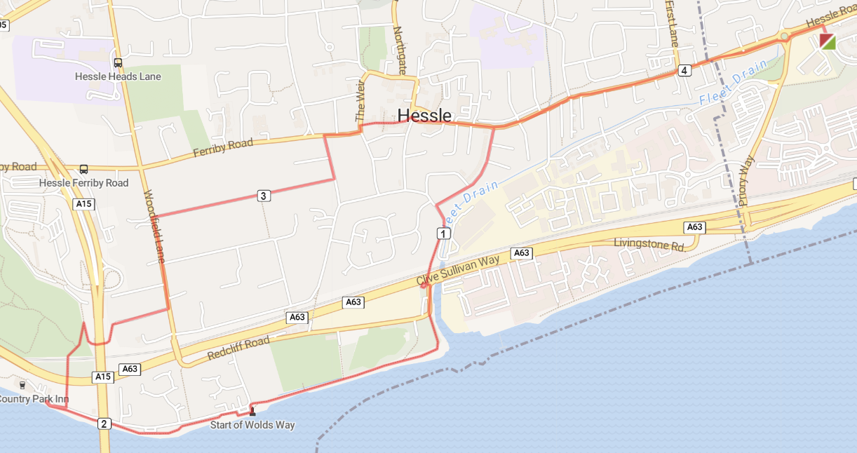
5 | 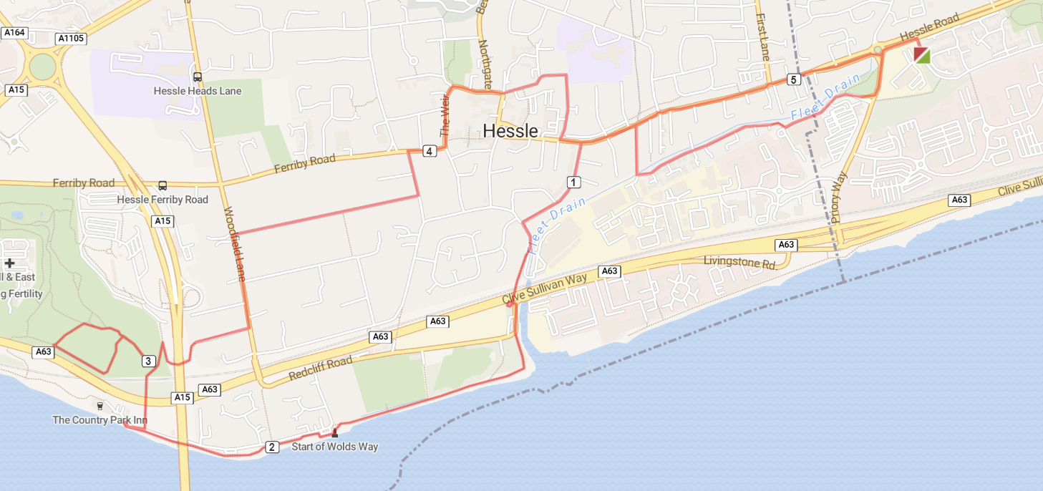
6 | 