Boothferry Fitmums Running Routes

Route 1A (Reverse) – HFRS Base

Exit base and cross to other side of Summergroves Way, Caution crossing road, R Summergroves Way, L Santolina Way, follow road round to right, R Robinia Drive, R Summergroves Way and back to base.  BoothFM - Route 1A; 1mile. Mapometer.com running route #5489841 | 1 mile
Exit base and cross to other side of Summergroves Way, Caution crossing road, R Summergroves Way, L Santolina Way, follow road round to right, R Robinia Drive, L Summergroves Way, L Impala Way, R Gemsbok Way, L Summergroves Way, Caution: cross road with care, R Forester Way, L Summergroves Way, Caution: cross road with care, and back to base.  BoothFM - Route 1A; 2mile. Mapometer.com running route #5489853 | 2 miles
Exit base and turn R onto Hessle Rd, Caution: use care crossing road, L Pickering Rd, R Askew Ave, R Hessle Rd, L Summergroves Way, Caution: use crossing, along Summergroves Way and back to base.  BoothFM - Route 1A; 3mile. Mapometer.com running route #5489854 | 3 miles
Exit base and turn L onto Hessle Rd, Caution: use care crossing road, R APRS, R Boothferry Rd, Caution: use crossing, L Pickering Rd, R Anlaby Rd, R Belgrave Drive, R Boothferry Rd, L Pickering Rd, Caution: use crossing, L Hessle Rd, R Summergroves Way Caution: use crossing. Back to base  BoothFM - Route 1A; 4mile. Mapometer.com running route #5489855 | 4 miles
Exit base and turn L onto Hessle Rd, Caution: use care crossing road, onto Hull Road, R Northolme Rd, R Beverley Rd, R Boothferry Rd, L First Lane, Caution: use crossing, R St Thomas More Rd via snicket, L Sibelius Rd, R APRN, Caution; cross road with care, L Boothferry Rd, R Askew Ave. Caution; use crossing, R Hessle Rd and back to base. Caution; cross road with care.  BoothFM - Route 1A; 5mile. Mapometer.com running route #5489857 | 5 miles
Exit base and turn L onto Hessle Rd, Caution: use care crossing road, onto Hull Road, R Eastgate, Caution: narrow paths onto Swinegate, R Northgate, Caution: narrow paths, L Swanland Rd Caution: wet leaves in winter, R Pulcroft Rd, R Boothferry Rd, L First Lane, Caution: Use crossing, R Hull Rd, R Spring Gardens, L Rokeby Ave, R APRN, Caution: cross road with care, L Boothferry Rd to roundabout, R Pickering Rd, R Hessle Rd and back to base. Caution: cross road with care  BoothFM - Route 1A; 6mile. Mapometer.com running route #5489861 | 6 miles

ROUTE 1A
1 | 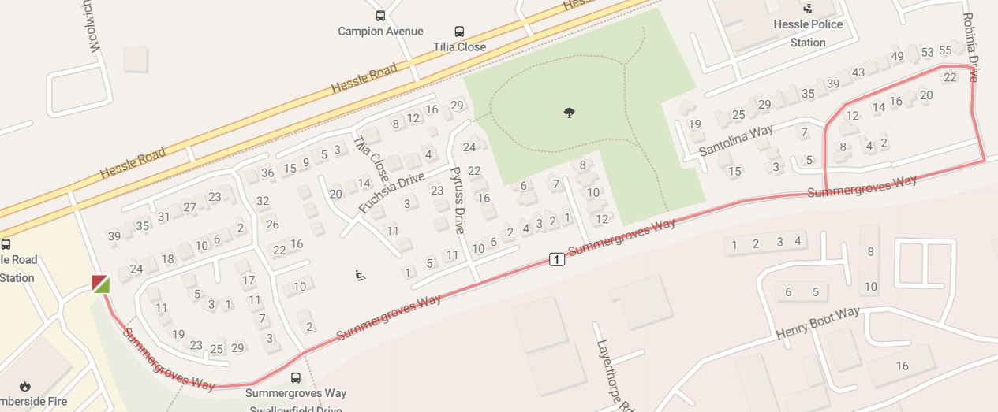
2 | 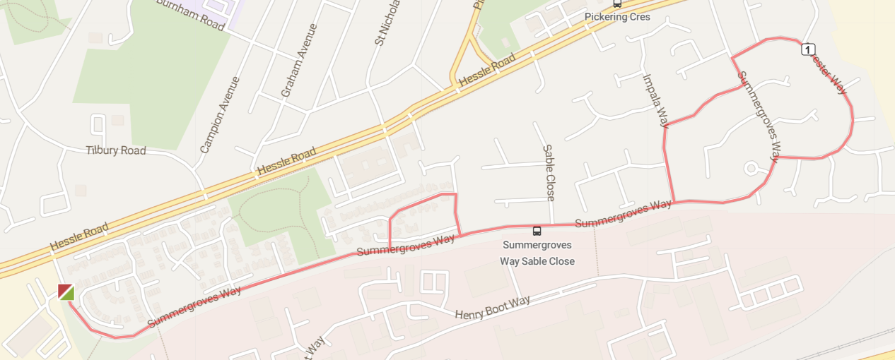
3 | 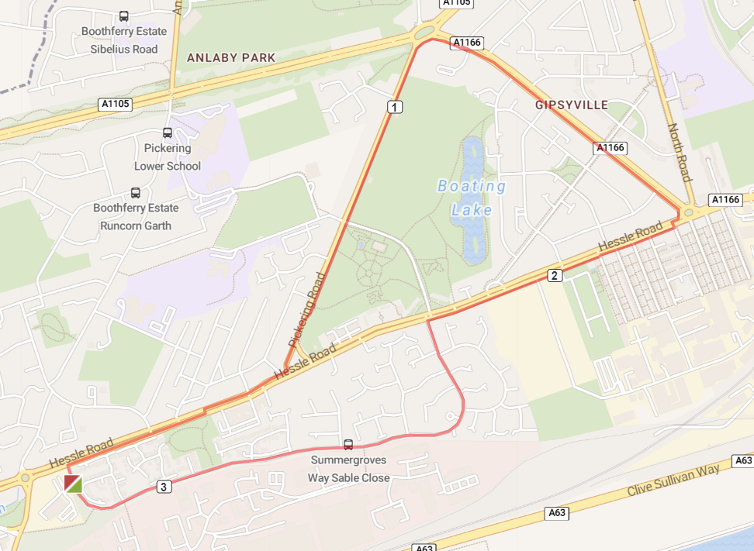
4 | 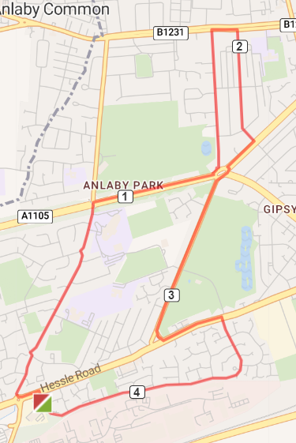
5 | 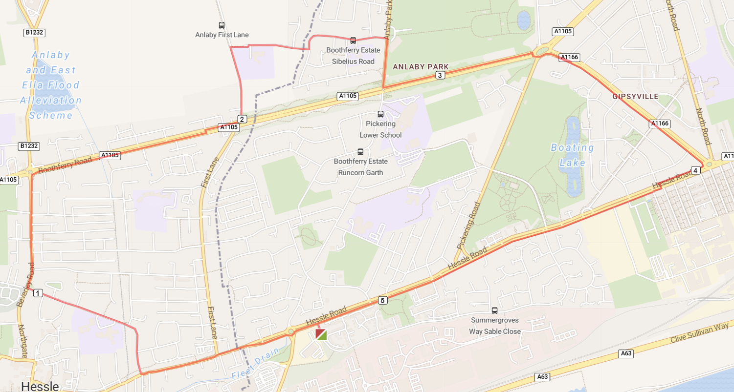
6 | 