SJF – SUMMER ROUTE 1 – 1 MILE

https://gb.mapometer.com/running/route_5517092.html

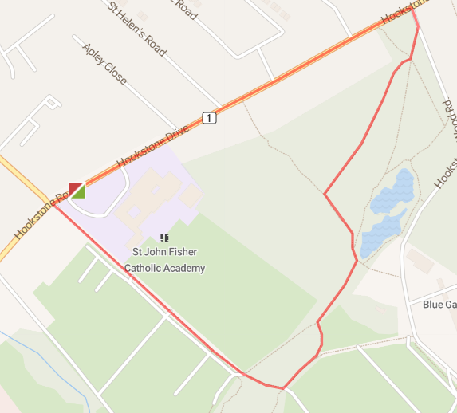

L out of school grounds (use path) – L at traffic lights onto Coach Road – through gate and continue straight ahead (watch for cyclists/pedestrians) – L at end – follow path and bear L at blue sign (watch for low tree branches) – R onto path (watch as woodland path) – L onto path (keep left) – R and straight on until end of wood – L onto Hookstone Wood Road (watch as no footpath) – L onto Hookstone Drive – back to base.
SJF – SUMMER ROUTE 1 – 2 MILE

https://gb.mapometer.com/running/route_5515567.html

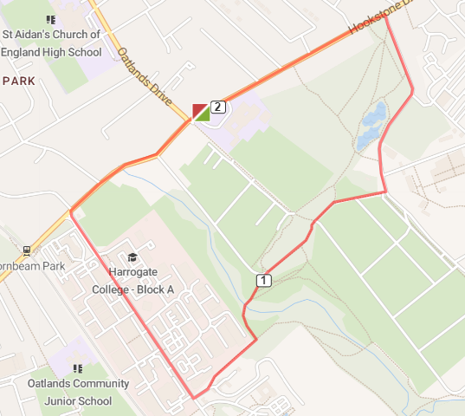

L out of school grounds (use path) – at 2nd set of traffic lights cross road and head L down Hookstone Road – use crossing over Rayleigh Road – then use 2nd crossing to turn L across Hookstone Road onto Hornbeam Park Road – follow road – L onto footpath (opposite The Zone building) – follow paved path all the way to the end – L then through gate follow paved path all the way to end. Turn left, through gate across squash club car park (watch for cars) – follow Hookstone Wood Road (watch as no footpath on part) – L onto Hookstone Drive – back to base.
SJF – SUMMER ROUTE 1 – 3 MILE

https://gb.mapometer.com/running/route_5514773.html

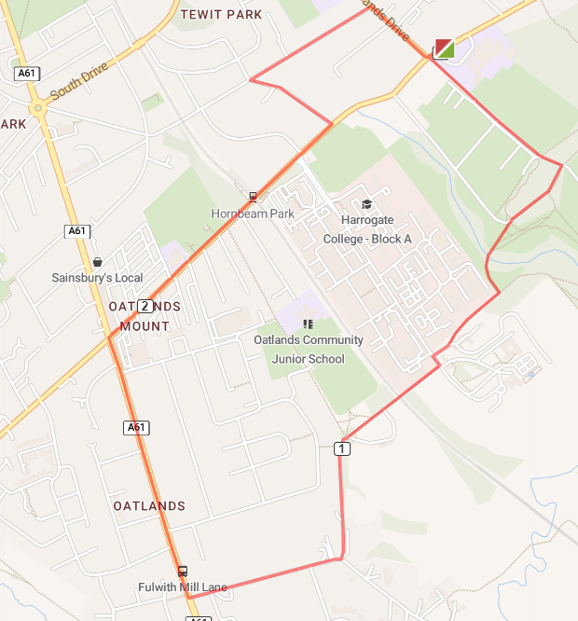

L out of school grounds (use path) – L at traffic lights onto Coach Road – through gate and continue straight ahead (watch for cyclists/pedestrians) – R at end – follow paved path until Hornbeam Park Avenue (opposite Indulge) – cross road – turn L then R quickly at blue sign (Almsford Bank/Stone Rings) – follow path over railway (watch as can be muddy and uneven) – onto paved path to Fulwith Mill (signed Harrogate Railway – watch for speed bumps) – R onto Fulwith Mill Lane (wide road but no footpath so run facing oncoming traffic) – R onto Leeds Road – R onto Hookstone Road – use crossing on railway bridge – L onto Hornbeam Crescent – R onto Wheatlands Road East – R onto Oatlands Drive to end – cross Hookstone Road – L back to base.
SJF – SUMMER ROUTE 1 – 4 MILE

https://gb.mapometer.com/running/route_5516397.html

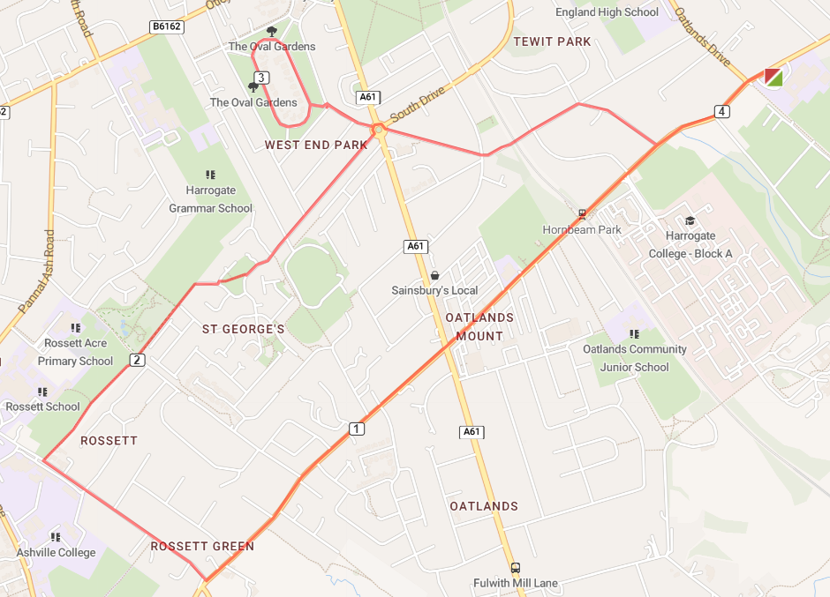

L out of school grounds (use path) – follow road to Leadhall Lane – over crossing with Leeds Road – R onto Green Lane – R onto cycle path towards Rossett (opposite Ashville School sign) – cross over Rossett Drive and follow path – L at Blenheim Court to cross diagonally over grassed area – L onto St George's Road (down side of the cricket club) – take 1st L at roundabout onto Park Drive – over Phillipa’s Drive onto The Oval for one circuit – R onto park Drive – L to cross over A61 onto Langcliffe Avenue onto Wheatlands Road East – R onto Hornbeam Crescent – L onto Hookstone Road – return to base.

