MARKET WEIGHTON 3 mile routes

ROUTE A https://gb.mapometer.com/running/route_5265953.html
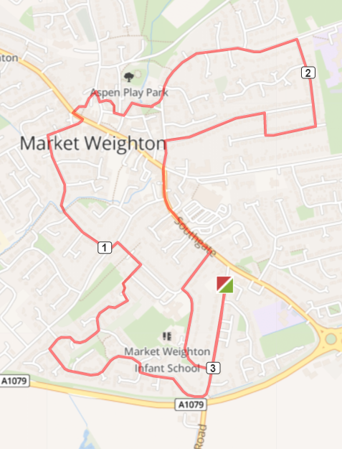
Turn R out of base onto Cliffe Rd, R Shipman Rd – continue on this, bear right at junction with Potter Close to continue on Shipman Rd, L Princess Rd, L Hawling Rd R Croft Close – over bridge onto Glenfield Ave, R Holme Rd, L Marketplace, R thru carpark to join Londesborough Rd – turn R when you reach it L Church Close – bear L to stay on Church Close, L Church Side, L St Helens Square, L The Green, L Spring Road, R Hill Rise onto Hill Rise Close, Hill Rise Drive R Hill Rise Drive (don’t miss this else it’s a dead end), L Hill Rise, L Finkle Street – straight onto Southgate, R Princess Rd – then bear L to continue on Princess Rd (don’t miss this turn) L Cliffe Rd back to base
Cautions - very uneven pavements along the route.

ROUTE B https://gb.mapometer.com/running/route_5265954
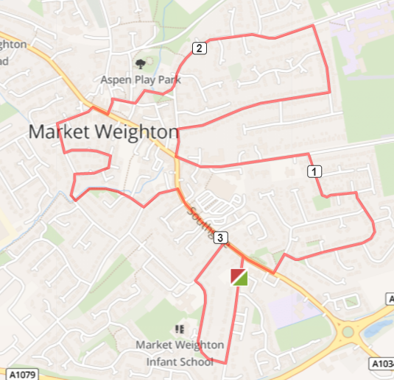
R out of base onto Cliffe Rd, R Princess Rd - keep right on Princess Rd, R onto Southgate - continue to Sancton Rd, L Langdale Rd, R Bedale Rd, L Lysander Drive, L Beverley Rd, R Finkle St, R Hill Rise, L Hill Rise, L Spring Rd, R The Green, R St Helens Square, R Church Close L Londesborough Rd, R Market Place, L Holme Rd, L Glenfield Ave
L Ash Grove onto Beech Close, L Glenfield Ave – cross bridge and turn L along Beck to Scotts Croft keep L Hawling Rd, R Southgate R Cliffe Rd to base

Cautions - very uneven pavements along the route

ROUTE C ALL YEAR https://gb.mapometer.com/running/route_5311581.html
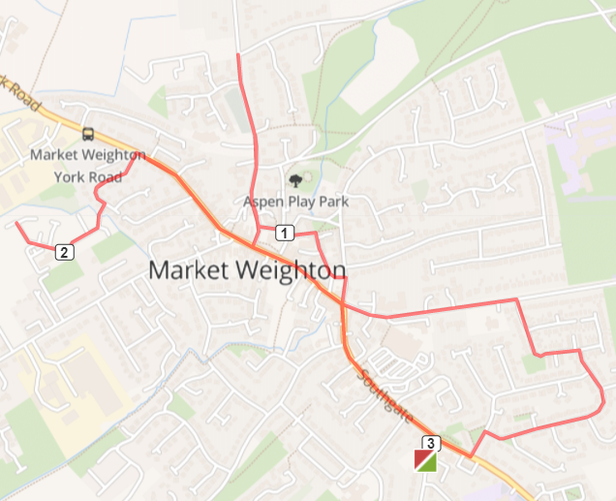
Turn L out of base to T-junction cross road, R Southgate cross over zebra-crossing L Langdale Rd, cross the road R Bedale Rd L Lysander Dr, L Beverley Road to roundabout, R Finkle St, cross road, L The Archway, continue onto Church Close, T-junction R Londesborough Rd, continue on Londesborough Rd until Goodmanham Rd STOP and return back to T-junction Market Place turn R. Continue onto York Rd crossing over where safe to turn L Northgate Vale, R Medforth St continue to end STOP and retrace route back to York Rd, continue Market Place, High Street roundabout R Southgate, continue back to base R turn on Cliffe Rd.

Cautions: uneven paths, low lighting in some areas, crossing main roads

ROUTE C SUMMER https://gb.mapometer.com/running/route_5265956.html

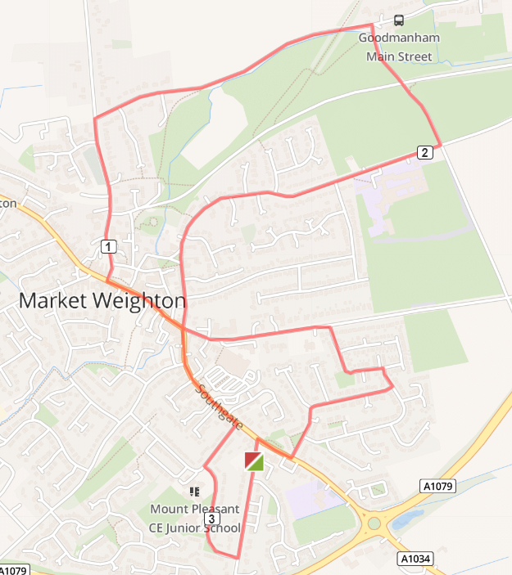
Turn L out of base, R Southgate cross over pelican crossing L Langdale Rd, R Wold Avenue, L Bedale Rd, L Lysander Dr, L Beverley Road continue onto High St – onto Marketplace. R Londesborough Rd, R Goodmanham Rd, R Red Lane Caution no footpath. L onto Spring Rd, L Finkle St, mini roundabout straight onto Southgate, Cross road at pelican crossing, R onto Princess Rd, L Princess Rd, follow round and L Cliffe Rd back to base.

Cautions going under bridge at Goodmanham as no footpath and country road up Red lane.

ROUTE D https://gb.mapometer.com/running/route_5265955.html

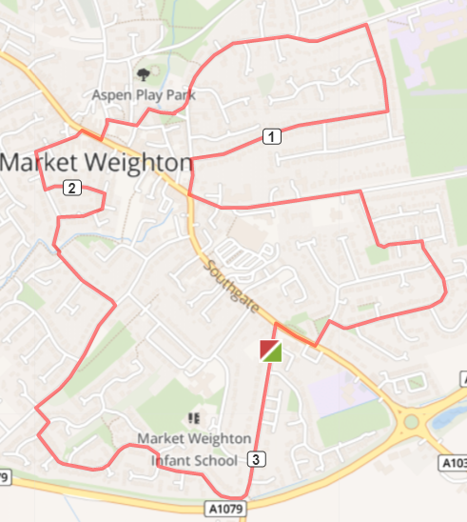
L out of base onto Cliffe Rd, R Sancton Rd, L Langdale, R Bedale Rd, L Lysander Drive, L Beverley Rd, R Finkle St, R Hill Rise – bear L onto Hill Rise L Spring Rd, R into The Green, R St Helen’s Square, R Church Close, L Londesborough Rd, R Market Place, L Holme Rd, L Glenfield Ave, L Ash Grove – onto Beech Close L - Onto Glenfield Ave – cross bridge onto Croft Close, R Hawling Rd L turn into cut through to Shipman Rd (opposite Sweep Close) then turn R Take first L continuing on Shipman Rd, Follow all way to Cliffe Rd, BACK TO BASE

Cautions - very uneven pavements along the route

ROUTE E https://gb.mapometer.com/running/route_5269054.html
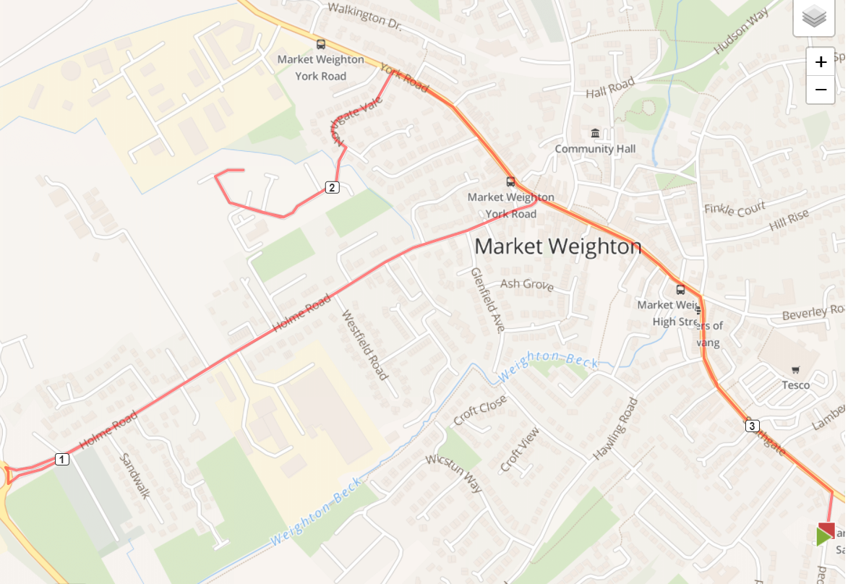
Turn L Out Of Base Onto Southgate, Turn L At The Roundabout Onto High St,
Turns Into MarketPlace, Take L On Holme Rd And Continue Down To The Bottom,
Cross The Rd At The Vets, R, Continue Back Up Holme Rd,
Turn L At Giant Bradley Statute Onto York Rd, Turn L Onto Northgate Vale, Continue And Take A R Onto Medforth St, Continue To Bottom, Past Doctors And Run Round Cul De Sac And Then Continue Back On Yourself. Back Up Medforth Street, Northgate Vale.
R Onto York Road, Continue Straight Onto Market Place, High Street, Take A R At The Roundabout Onto Sancton Rd, R At Cliff Rd, Back To Base.
Cautions, Use Crossing To Cross And Care On Uneven Pavements.
ROUTE F 3 mile MW FM 3 Mile Route F . Mapometer.com running route #5396063

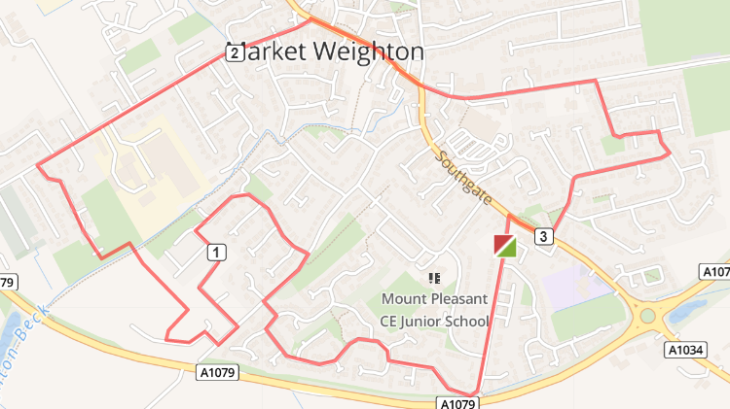

Turn R out of base onto Cliffe Rd, to the end bear R onto Shipman Rd. At the T-Junction where road divides take R to continue Shipman Rd, continue to follow Shipman Rd T-junction R then L take the snicket pathway from Shipman through to Sweep Rd (caution bollards, low light) R on Sweep Rd, L onto Wicstun Way. Follow Wicstun Way keep turning L until turns in Butler Drive, R Sweep Rd, to end R Ombler Drive, 1st R Beales Close (over Weighton Beck) L Coperland Crescent, R Sandholme to end R Holme Rd, T junction R Market Place onto High Street use zebra crossing to cross over to LHS High Street, continue to mini roundabout, straight over to Beverley Rd, R Lysander Drive, R Bedale, R Wold Ave, slight L Langdale Rd, T-junction R onto Sancton Rd, use zebra crossing cross road, L Cliffe Rd back to base.

Cautions –
Caution bollards, narrow path low light on snicket from Shipman to Sweep Lane
very uneven pavements along the route, some new road surface areas with high kerbs, low lighting (Beales Close area)
caution cross over roads use zebra crossings on High St and Sancton Rd

